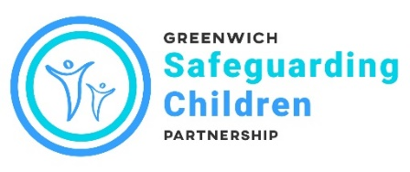
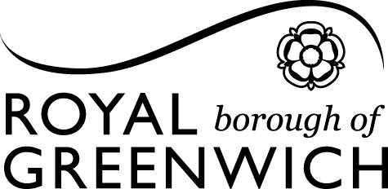

Inter-Agency Referral Form for Early Help or Children Social Care Services

This form is to be used to make a referral about a child or young person for either Early Help or Children Social Care Services. Before contacting the Multi Agency Safeguarding Hub (MASH) you need to consider whether the child or young person's needs can be met by services from within your own agency, referring to a specific service, or by other professionals already involved with the family

Is the child at immediate risk of serious harm or injury? If so call 999 and ask for police
If you have an urgent safeguarding concern, please contact us by telephone (020 8921 3172) immediately, do not wait to send the form.
All telephone referrals should be followed up in writing within 24 hours by completion of this form.

CONSENT: Agencies who are making enquiries and/or making referrals about child(ren) should inform the parents/carers or those with parental responsibility that they are making a referral to Children Services, unless to do so would mean that the child or young person is at greater risk
Have you sought consent for this referral from the parent or carer with parental responsibility?

If YES please name the person who has provided consent
If NO please explain why

Referring agency details:
Name of Referrer |  | Job Title
Agency: |  | Address:
Tel/Mobile: |  | Email:
Date:
Have you discussed this with your agency safeguarding lead? Yes No
(this should not delay a referral being made)
Name of Lead:
Email / Phone:

Child(ren)’s / Young Person’s details
Last Name | First Name | DOB/EDD | Gender | Ethnicity | Early Years /  Educational Setting / UPN
Child(ren)’s / Young Person’s main carers / significant others
Last Name | First Name | DOB | Gender | Relationship to child | Tel/Email | Parental Responsibility  Yes/No
Address(es)

GP / Surgery | Address / Tel | NHS No  (if known)

Languages spoken
Is an Interpreter required?
Family Immigration Status

Does the child / young person / parent(s) / carer have an Yes No Not known
additional need or disability

If yes, is it a long-term need/disability (please indicate) Yes No

Details of need/disability (if applicable)

Does the child / young person / parent / carer have a special educational need Yes No

Does the child/young person have an Education and Health Care Plan (EHCP) Yes No

What are your worries regarding this child / family

Risks
Please tell us your opinion of the level of risk to the child and detail explicitly your reasoning for this | Low Medium High
What is working well for this child / family?

Parent’s / child(ren)’s / young person’s views
What involvement have you and any other agencies had in the support and protection of this child/family? Please list names and contact details where possible (YOS, CAMHS, Health Visitor, education settings, other local authority etc).
What do you want to be different for this child / young person / family?

Please email this form securely to MASH

Duty Team: 020 8921 3172
Consultation line for professionals: 020 8921 2267
Out of hours: 020 8854 8888
Email: MASH-referrals@royalgreenwich.gov.uk (please only send information to this email address using a secure email system, e.g. Egress)
MASH-referrals@royalgreenwich.gov.uk.cjsm.net

Royal Borough of Greenwich MASH Team, 1st Floor, The Woolwich Centre, 35 Wellington Street, London SE18 6HQ

To help you to determine levels of need when making your own assessment, please refer to the threshold document www.proceduresonline.com/greenwich/cs/p_threshold.html?zoom_highlight=threshold

