**Greenwich Safeguarding Children Partnership**

**Inter-agency Escalation Policy**

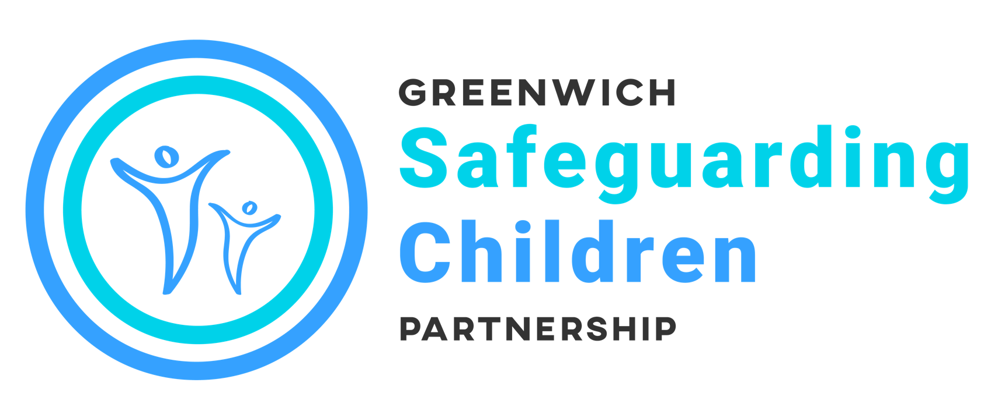

**The Resolution of Professional Inter-agency Disagreements about Safeguarding Children**



**Introduction**

Occasionally situations arise when workers within one agency feel that the actions, inaction or decisions of another agency do not adequately safeguard a child. Disagreements are most likely to arise around:

* Levels of need/thresholds
* Roles and responsibilities
* Decisions made at a Child Protection Conference or Core Group meeting
* Progressing plans
* Communication

All professionals have a duty to act assertively and proactively to ensure that a child’s welfare is the paramount consideration in all professional activity.

Therefore all professionals must challenge the practice of other professionals where they are concerned that this practice is placing children at risk of harm.

Resolution should be sought within the shortest timescale possible to ensure the child is protected. Disagreements should be resolved at the lowest possible stage however if a child is thought to be at risk of immediate harm the designated safeguarding lead in your agency should be informed immediately.

**Stages of the policy**

Professionals should attempt to resolve differences through discussion within a timescale that protects the child from harm.

**Stage One – involving your line manager**

Any worker who feels that a decision is not safe or is inappropriate should initially consult a supervisor/manager to clarify their thinking in order to identify the problem, to be specific as to what the disagreement is about, and to identify the desired outcome.

**Stage Two – involving the worker from other agency/service**

The professional with concerns should raise the matter directly with the relevant practitioner. They should give clear evidence-based reasons for their disagreement. This discussion must take place as soon as possible and could be a telephone conversation of a face to face meeting. There may be instances where disparity in perceived status or experience may inhibit the ability of some workers to resolve the disagreement without support.

**Stage Three – escalate line manager to line manager**

If the problem is not resolved at stage two the worker should contact their supervisor/manager within their own agency who should have a discussion with the equivalent supervisor/manager in the other agency.

**Inter-agency Escalation Policy**

2

**Stage Four – escalate to named/designated safeguarding leads or senior operational manager.**

If the problem is not resolved at stage three the supervisor/manager reports to their respective operations manager or named/designed safeguarding representative. These two managers must attempt to resolve the professional differences through discussion.

**Stage Five – escalate to operational directors/assistant directors**

If the problem is not resolved at stage four, the operations manager or named/designated safeguarding representative reports to their respective operational directors/assistant directors who must attempt to resolve the professional differences through discussion.

**Stage Six – resolution by Greenwich Safeguarding Children Partnership (GSCP) Chaired meeting.**

Operational issues must be resolved by the agencies directly involved in the case. When a resolution has not been achieved at the Partnership Team should be notified. They will advise the lead representatives of the safeguarding partners and arrange a meeting of the most senior managers with operational responsibility for the case with the Scrutineer. This meeting will review the issues at hand and provide a final opportunity for the involved agencies to ensure that there is a full understanding of the issues before the decision is finalised.

The Scrutineer will then report their findings to the Executive who will determine how learning can be disseminated. .



**Inter-agency Escalation Policy**

3

**Important Additional Notes**

At all stages of the process actions and decisions must be recorded in writing and shared with relevant personnel, to include the worker who raised the initial concern. This must include written confirmation between the parties about an agreed outcome of the disagreement and how any outstanding issues will be pursued.

At any point in the Escalation Process, a worker or manager may believe that the discussions have identified areas where there is the possibility of whole system learning. When that is the case, the matter should be discussed with the designated safeguarding lead/representative and if appropriate, brought to the attention of the to the attention of the learning from Cases group using (insert form) If the process highlights gaps in policies and procedure this must be brought to the attention of the Chair of the Learning from Cases Group. .

**Greenwich Safeguarding Children Partnership**

The Woolwich Centre,

1st Floor 35 Wellington Street,

Woolwich SE18 6HQ

Telephone 020 8921 4477  
www.greenwichsafeguardingchildren.org.uk

**Lewisham and Greenwich NHS Trust**

Named Nurse Safeguarding Children 020 8836 5370

**Oxleas NHS Foundation Trust (including CAMHS)**

Head of Safeguarding & Lead Named Nurse

01322 625009 / 07771 767102

Named Nurse Greenwich

020 8921 4420 / 07879 635510

Consultant Paediatrician & Named Doctor

020 8294 3144 or 020 8836 8621

**Key Contacts**

**Greenwich Children’s Social Care**

Multi-agency

Safeguarding Hub (MASH) 020 8921 3172

Out of Hours 020 8854 8888

**Safeguarding Co-ordinator** 020 8921 4438

**for Schools** 07805 704 113

**Early Help Manager** 020 8921 4590

**Adults’ Services** 020 8921 2304

**Metropolitan Police**

Child Abuse Investigation

Team (CAIT) 020 7230 3700

**Greenwich Clinical Commissioning Group**

Designated Doctor for

Safeguarding Children 020 3049 9001

Designated Nurse for

Safeguarding Children 07880055383

Named GP for

Safeguarding Children 020 3049 9001